**Alarm Detection System**

**Key Contributors:**

**Ruby Rodriguez, Osvaldo Garza, Marcus Harmon**



**[Date]**

**2-10-2022**

This project and the preparation of this report were funded in part by ….through an agreement with the University of the Incarnate Word.

Cyber Security Systems and the University of the Incarnate Word

# EXECUTIVE SUMMARY

Start of executive summary ……

The three of us (Ruby, Osvaldo, and Marcus) have decided to make a Raspberry-Pi room alarm detection system. Essentially the parts we will be using will notify the owner when his/hers safe is being tampered with by an outside source. The raspberry pi will be used at the center of the device sort of like the brain of the whole system. Connected to the raspberry pi will include a speaker, speaker amplifier, wifi doggle, USB camera, two led lights, a small revolving light, and finally a keypad. When the intruder or anyone entering the area of the safe the USB camera will activate by taking a picture of the area and sending an email to the owner alerting him/her that someone is trying to access the safe. When the intruder begins tampering with the keypad, resulting in a wrong passcode, the speaker will begin sounding a loud alarm as well as activating the revolving light alerting anyone the safe is under attack by an outside source.

Project Milestones: E.g. Major steps required to complete your project.

1. Finish the status report
2. Finalize our thoughts and ideas
3. Run website using visual studio code
4. Gather the parts that we need for the making of the project
5. Construct project (ask questions as need be)
6. Project runs smoothly and show to the class

Deliverables: E.g. Report, Deployed architecture, other project outcomes etc.

1. Complete and turn in status report
2. Construct the project
3. Record or show the class the final product of the project

Professional Accomplishments: E.g. New skills that you developed

1. How to work and be attentive to a team
2. How to use Trello for the present and the future
3. I learned how to use better communication skills in order to complete a common goal

# PROJECT SCHEDULE MANAGEMENT

Create a Gantt chart with the application of your choice and replace it with the picture presented below.

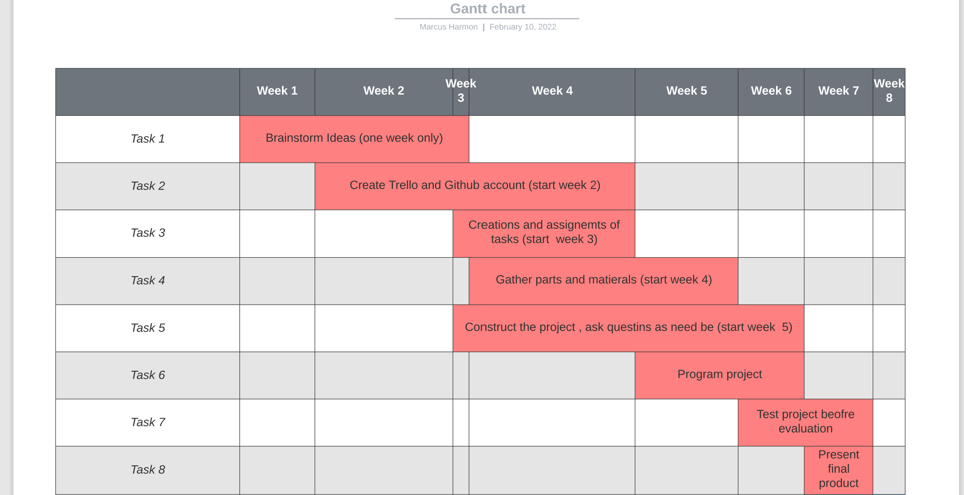

Project Management Board Link (QR Code Only). Send invite to user: @gonzalodparra

[IOT Project (monday.com)](https://marcus257603.monday.com/boards/2265654863/)

Create a Github Project Repository and add the user “cyberknowledge” as a contributor.

https://github.com/your_username/your_project_repo_name

# TABLE OF CONTENTS

[List]

[SECTION HEADER]

[HEADER 1**]**

[Body Text]

[Header 2]

[Body Text]

[Header 3]

[Body Text]



***Significant takeaways / Boxed text***

**TITLE PAGE TITLE** (Calibri, 20 R: 0 G: 32 B: 96)

**Authors / Contributors** (Calibri, 20, RGB Hex: cb333b)(Logos can be used)   
**Date** (Calibri, 20, RGB Hex: cb333b)

This project and the preparation of this report were funded in part by monies provided by CPS Energy through an agreement with The University of Texas at San Antonio.

©CPS Energy and the University of Texas at San Antonio

**-----------------------------------------------------------------------------------------------------------------------------**

**EXECUTIVE SUMMARY**(Cambria, 15.5 RGB Hex: 003960)

TEXT (Cambria, 12 Black)

Sub-Text (Calibri, 9.5 Black)

**TABLE OF CONTENTS** (Cambria, 15.5 RGB Hex: 003960

TEXT (Cambria, 12 Black)

Sub-Text (Calibri, 9.5 Black)

**-----------------------------------------------------------------------------------------------------------------------------**

SECTION HEADER

(SECTION HEADER: Cambria, 26 RGB Hex: 003960)

**HEADER 1** (Cambria, 15.5 RGB Hex: 003960)

**Header 2** (Cambria, 14 RGB Hex: 005a98)

Header 3 (Cambria, 13 RGB Hex: cb333b)

Body Text (Calibri, 10.5 Black)

***Boxed Text*** (Calibri, 9.5 Black Bold Italics)

*Letter of Transmittal Sample*

November 23,2021

University of The Incarnate Word

Attention: Dr. Gonzalo. D. Parra

4301 Broadway

San Antonio, TX 78209

Dear Dr. Parra:

With this letter, the team ____________ transmits the following items associated with the **CIS 3353 Final Project**.

**SCOPE OF WORK (dated 11/23/2021): “Title of Your Work”**

* DELIVERABLES related to the _______ sub-task:

Aim 1:

Deliverable 1

Deliverable 2

Aim 2:

Deliverable 1

Deliverable 2

Please share these with your team as appropriate. If you have any questions, please contact ________ at (210) 458-8618 or by email at _________.

Kindest regards,

Team Lead  
Student of Cyber Security Systems at the University of the Incarnate Word